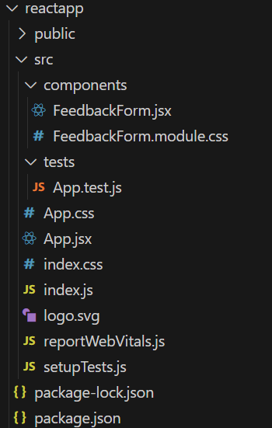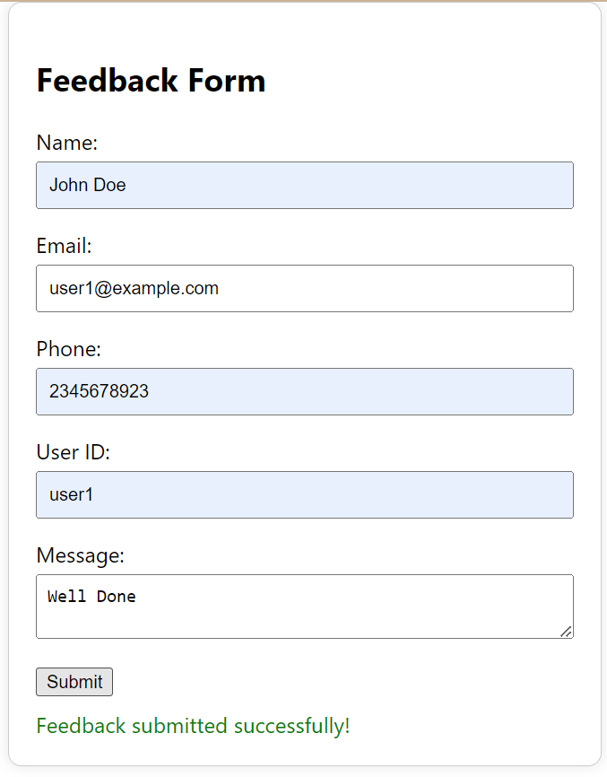  
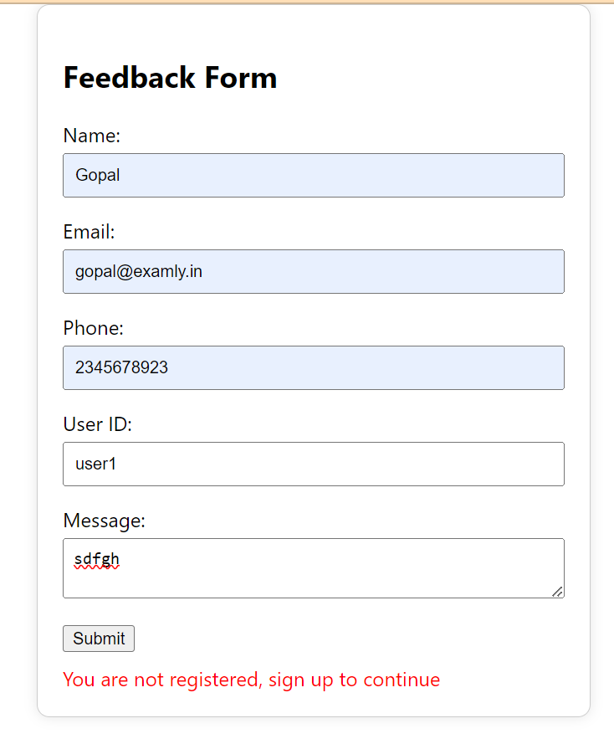

renders_feedback_form_heading_is_present

renders_form_fields_is_present

validates_required_fields_is_working

validates_email_format_is_working

displays_success_message_on_valid_submission

retains_form_fields_on_validation_errors

error_messages_disappear_on_correct_input

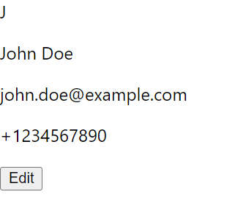



renders_profile_card_with_user_information

toggles_to_edit_mode_when_edit_button_is_clicked

calls_onEdit_when_save_button_is_clicked_in_form

shows_error_messages_for_invalid_form_submission

displays_success_message_on_valid_form_submission

resets_form_fields_after_successful_submission

error_messages_disappear_on_correct_input

